**Name : Abrar Rejwan Prince ID:22-48757-3**

**Database Lab Task**

**select \***

**from salgrade;**

**select deptno**

**from dept;**

**select ename, sal, sal+sal*.05 as "5%INCREMENT"**

**from emp;**

**select ename, sal+sal*.05 as "new salary"**

**from emp;**

**select \***

**from emp**

**where ename='BLAKE';**

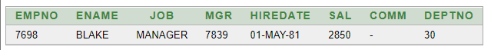

**select ename||' '||'is hired on'||' '|| hiredate ||' '|| 'as a '||' '|| job**

**from emp;**

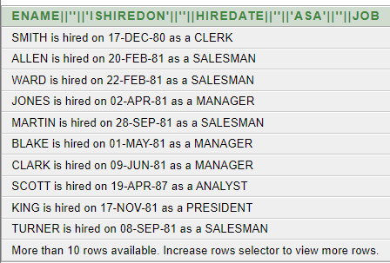

**describe bonus;**

**describe emp;**

**describe salgrade;**

**describe dept;**

**select distinct job from emp;**

